Embedded Systems
(Rough Draft)
Micheal H. McCabe
February 15, 2010

Introduction:

In general terms, an embedded system is a computer that is both dedicated to a particular task and packaged within another product. While this definition might seem particularly broad, it is important to remember that we are considering a range of systems that are incorporated into everything from birthday cards to life-sustaining medical equipment and interplanetary spacecraft. While embedded systems generally get very little attention in computer science courses, it is important to remember that of all microprocessors sold annually, only 2% are used in traditional desktop computers. The bulk of the remaining 98% are used in embedded applications.
For a computer programmer, the thought of creating an operating system for the next generation toaster-oven may not be as exciting as creating “must-have” applications for Microsoft or Apple Computer, but the need for such software does exist. Although objective statistics are hard to come by, it appears that much of the software for these embedded systems is developed by electrical engineers themselves. While this paradigm seems to have been successful overall, there have been a number of spectacular failures that resulted from a lack of familiarity with sound programming principles.
The intent of this paper is to briefly examine the history and development of embedded computer systems, to consider the current state-of-the-art, and to examine the process by which embedded systems are designed, prototyped, mass-produced, and ultimately used. As a criticism of the subject, special attention will be given to failures that can be attributed to oversights in the design of both hardware and software to fulfill not only the design specification, but the ultimate actual uses of the product.
A Brief History of Embedded Systems:

The essential purpose of an embedded system is, to one degree or another, that of automatic control. Self-governing machines are nothing new, but the degree to which a system can now be made autonomous is largely a function of the microcomputer system embedded in its control mechanism. When I refer to a microcomputer system, I refer to a synthesis of both hardware and software; since one is intrinsically useless without the other.
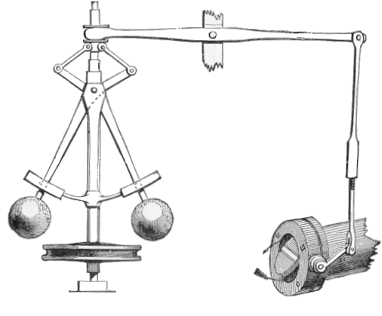
An early centrifugal control system used to regulate the speed of an engine.
(Drawing taken from Wikipedia, Originally appeared in "Discoveries & Inventions of the Nineteenth Century" by R. Routledge, 13th edition, published 1900.

Although mechanical control systems have existed since antiquity, the earliest known formal study of the concept dates to the late 1860's when the physicist James Clerk Maxwell began a dynamical analysis of the centrifugal governor used to regulate the operation of rotating machinery. The classic “fly-ball” governor consists of two massive weights connected by a pantograph linkage to a central shaft. As the velocity of the rotating shaft increases, the kinetic energy transferred to the weights also increases, allowing them to move outward and upward against the force of gravity. This movement is transferred through the pantograph linkage to a thrust bearing that moves up and down on the central shaft. The movement of the thrust bearing is translated by a beam linkage to linear motion that can then be used to operate a throttle, limiting the flow of steam, fuel, or any other working fluid that the speed of the engine is dependent upon. As the engine slows in response to this throttle action, the “balls” lose kinetic energy and move downward and inward in response to gravity. This motion is likewise transferred through the linkages and opens the throttle, allowing more working fluid into the engine and thereby increasing its speed. Although this type of governor had been used for centuries to control the speed and relative spacing of the grindstones in grist mills, it was improved and employed by James Watt to control the speed of his steam engines beginning in 1788.
Although the intelligentsia had yet to create the esoteric fields of systems theory or control theory, it was well understood by the early 19th century that the centrifugal governor itself was a useful analogue for many natural, social, and industrial processes. The naturalist Alfred Wallace, in a letter to the Linnean Society, wrote of the evolutionary mechanism:
The action of this principle is exactly like that of the centrifugal governor of the steam engine, which checks and corrects any irregularities almost before they become evident; and in like manner no unbalanced deficiency in the animal kingdom can ever reach any conspicuous magnitude, because it would make itself felt at the very first step, by rendering existence difficult and extinction almost sure soon to follow.
While he was not the first to make note of this principle, Maxwell was intrigued by the operating principles of the governors themselves. In particular, he noted a discernible lag in the operation of the centrifugal governor that caused the speed of the governed engine to “hunt” – in other words to oscillate above and below the reference point. This malfunction, largely attributed to friction and mechanical delay in the control system itself, allowed him to make an initial application of mathematical theory to the practical concept of machine control. His descriptions of the various types of control machinery, as well as the mathematical properties that governed their operation, made it possible to create a basic abstraction of the control mechanism and to to develop a generalized mathematical model of that abstract control mechanism.
The schematic representation of the centrifugal governor, or any control mechanism that is dependent upon negative feedback, is usually drawn as follows:

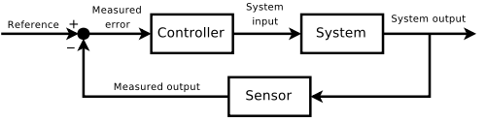

The Free Online Dictionary of Computing (FOLDOC) defines an embedded system as follows: Hardware and software which forms a component of some larger system and which is expected to function without human intervention. http://foldoc.org/embedded+systems. Retrieved 2010-02-15
Turley, Jim (18 December 2002). "The Two Percent Solution". Embedded Systems Design. TechInsights (United Business Media). http://www.embedded.com/shared/printableArticle.jhtml?articleID=9900861. Retrieved 2010-02-15.
Maxwell, J.C. (1867). "On Governors". Proceedings of the Royal Society of London 16: 270–283. doi:10.1098/rspl.1867.0055. http://links.jstor.org/sici?sici=0370-1662(1867%2F1868)16%3C270%3AOG%3E2.0.CO%3B2-1. Retrieved 2010-02-14.
Hills (1996), Power From the Wind, Cambridge University Press
Tann, Jennifer (2004). "James Watt (1736–1819)". Oxford Dictionary of National Biography. Oxford, England: Oxford University Press.
Wallace, Alfred Russell. "On the Tendency of Varieties to Depart Indefinitely From the Original Type". http://www.wku.edu/~smithch/wallace/S043.htm. Retrieved 2010-02-15.

