Principles of System Operation and Administration
CSCI - 280 Section 001 / Fall 2009 / CRN 10423 / Professor David A. Tucker

Student Workgroup

Jeffrey Salvatore & Micheal H. McCabe

With Special Acknowledgements to:
news://alt.sysadmin.recovery/


Document Outline and Table of Contents
(Preliminary)

Hardware Installation

Hardware Configuration

Software Installation

Software Configuration

Network Configuration

Running a Production System

Maintenance and Upgrades

Troubleshooting

Backups

Glossary

(This page is NOT entirely blank.)

I. Hardware Installation

For purposes of this exercise in basic system operation and administration, we are configuring a local area network (LAN) consisting of four individual commodity-grade Intel Pentium-IV personal computers. The individual system "towers" are stored four-abreast in a rolling wireframe cart with a keyboard-video-mouse switch (KVM), CRT (cathode-ray-tube) monitor, PS-2 keyboard, mouse, switched network hub, power strip, and associated cabling. Each system is equipped with a network interface, memory, a single hard drive, optical drive, and floppy disk drive. Each CPU motherboard is equipped with a typical variety of onboard peripheral controllers and legacy I/O ports.
The hardware has essentially been pre-configured for this class and appears to have been re-purposed from a previous incarnation of the second-floor Doucette Hall Math & Computer Science laboratory. The computers appear to be in overall good shape, although some hardware failures were identified on September 9, 2009 while attempting to complete preliminary software installations for this class.
<INSERT PHOTOGRAPH OF SYSTEM HARDWARE "RACK" HERE>
<INSERT TABLE OF HARDWARE CHARACTERISTICS & SPECIFICATIONS HERE>

Hardware Configuration

As with the hardware installation, much of the hardware configuration process has already been completed prior to our arrival on the scene. Configuration tasks during our first laboratory exercise on September 9, 2009 were limited to modification of BIOS settings for boot sequence (allowing us to boot the individual systems from the optical drive) and addressing some cabling issues with the network switched hubs and KVM switches. By far, the most serious problem encountered with hardware configuration was the provision of electrical power to the system carts. The limited number of electrical outlets in the room, combined with generally crowded conditions, made it necessary to get "creative" with power strips -- daisy chaining them together to get power to each of the systems.
From an electrical and fire safety standpoint, this is generally unacceptable and should be rectified for future classes. Although no life-safety issues were encountered on September 9, 2009 there were a number of inadvertent system crashes due to power failure when power cords were unexpectedly pulled from outlets. The "daisy chain" approach also poses a risk of electrical overload. Crowding within the room made it necessary to step over tables, chairs, and stretched cabling to move about or exit the room. This in itself presents a "trip and fall" hazard to say nothing of the difficulties that might occur if a rapid egress from the room becomes necessary.

BIOS (Basic Input / Output System) Configuration:
In order to install any operating system from the distribution CD, it is generally necessary to reboot the system from the CD rather than the more typical startup from the internal hard drive. Some systems were already configured to boot from the optical drive but others needed to have the BIOS reconfigured to allow the system to start from the CD-based installation volume. To make these changes, it is first necessary to restart system (if running) and access the ROM-based BIOS setup utility.
The original equipment manufacturer for these particular systems was Gateway. The general procedure for entering the BIOS setup utility on recent-model Gateway computers is to press the F1 or F2 keys at one-second intervals during the power-on self-test (POST.) If you simply hold either key down during the POST, the BIOS is likely to report a "keyboard error." On a humorous note, some machines report "No keyboard present. Press any key to continue."
The system BIOS controls all of the hardware integrated into the motherboard as well as major hardware devices such as ATA/IDE, Serial ATA, AGP and PCI video cards, processors, and memory which plug into the motherboard. The BIOS enables operating systems to use its services to communicate with hardware. The BIOS offers menus which enable a wide range of hardware types to be configured.
A BIOS setup program customized to the BIOS used on a particular system is used to configure the hardware in the system. The BIOS setup program lists various configuration menus (disk drives, special performance settings, startup settings, and so on) and the user selects the desired items from each menu.
The CMOS is the popular name for the non-volatile memory chip and real-time clock (NVRAM/RTC) chip on the motherboard which store BIOS settings. A battery on the motherboard powers the CMOS chip to enable it to store information when the system is turned off.
Each motherboard is configured with BIOS defaults. Generally, these settings provide for stable operation at the expense of system performance. BIOS defaults might also cause a system to operate at speeds much slower than the processor and memory are designed to support. Other terms for BIOS default settings are system default, optimal defaults, and fail-safe. You can configure this option with a single keystroke from most BIOS setup menus. If such documentation is available, see your system manual or BIOS setup menu help for details.
The following example images of BIOS setup screens were taken directly from the manufacturer's website and are not specific to computers in this classroom. They are intended to illustrate the CMOS options and settings needed to configure the computers for installation of the operating systems used in class. "Fair Use" copyright exemptions (for illustrative and educational purposes) are claimed here for intellectual properties held by Gateway, Inc. and Award Software (See appendix for contact information.)

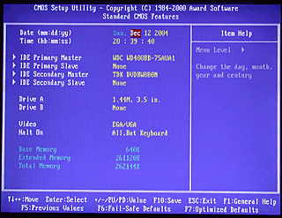
Figure : Standard CMOS Features (Award BIOS)
Most system BIOSes offer various auto-configuration options which primarily affect memory and processor speed settings. To select slower but more stable performance, select BIOS defaults. To improve system performance, select options such as Hi-Performance, Optimum, Best Performance, Turbo, and so on. See your system manual or BIOS setup menu help for details. If your system becomes unstable with higher-performance settings, restart the BIOS setup program and select BIOS defaults or similar options.
Depending upon the BIOS options available, you can also configure most of the settings in a particular system, such as processor and memory speed and timings, hard disk configurations, integrated ports, and so on. If your system becomes unstable after you select user-defined options in your BIOS, restart the BIOS setup program and select BIOS defaults or similar options. Selecting any automatic BIOS configuration wipes out most user-defined settings. Make user-defined settings after using an auto-configuration option.
Many recent BIOSes also contain features which can help you to manage your system and prevent system failures. The PC Health or Hardware Monitor menu displays system voltages, cooling fan performance and processor temperature information. S.M.A.R.T. monitoring of hard disks warns of hard disk failure before it takes place. By using system monitoring program within Windows, you can receive alerts warning of overheating, fan failure, out-of-range voltage conditions and imminent hard disk failure.
On modern systems with the BIOS stored in NVRAM instead of mask-programmed ROM, PROM, or EPROM it is theoretically possible to install BIOS upgrades and patches. Practically speaking, the manufacturing life-cycle for motherboards is so short that production has often ended by the time an OEM system comes to market. Support is frequently spotty -- particularly with system integrators that frequently change suppliers. If your system is stable and properly operates with the hardware and operating system it contains, there is usually no need to update the system BIOS. However, if certain hardware devices, memory speeds, processor types or speeds are not recognized or do not work properly, a BIOS upgrade is necessary to provide proper operation. Contact your system or motherboard vendor for BIOS upgrades.
In most BIOS setup programs, you use arrow keys to move from option to option. Usually, you press the Enter key to enter a submenu. To change a menu option, you might use plus (+) and minus (-) or Page Up / Page Down keys. Use the Esc (Escape) key to return to the previous menu. If the system uses a top-level menu for different pages, use the arrow keys to move to a different menu page. Function keys are often used to set various automatic setup options or to save changes. See on-screen help for details.
If you make any changes to existing BIOS setup options, note the setting you changed. The most critical settings include hard disk configuration, memory and AGP settings, and power management. A digital camera with a close-up (or MACRO) focus setting is a convenient way to record BIOS screens before and after changes are made.
The standard BIOS Setup menu provides the bare minimum of configuration needed to get a system running. This includes date and time setting, ATA/IDE hard disk configuration, and configuration of other ATA/IDE drives such as CD-ROM and removable-media drives. Some systems display the memory size they detect and might offer a few other options on this screen. Some systems display this screen first, while others display a menu screen offering this as the first option.
Set the time using a 24-hour clock with most systems. For example, 1:05PM is the same as 13:05. The date is set by selecting the month, date, and year in separate fields. If you change date and time in Windows, the changes are reflected here. A potential conflict when running multiple operating systems is that Windows expects to find local time stored in the hardware TOY (time-of-year) clock and Unix derivatives expect to find GMT in the hardware clock. This can cause conflicts with various administrative settings and the scheduling of routine jobs like disk defragmentation, disk indexing, and automatic backups.
Some systems offer an option to adjust for Daylight Savings Time. This should be left disabled, as Windows XP and other recent versions make the adjustment for you. If the operating system and the BIOS both attempt to adjust for DST, your system clock will not be set correctly.
To save setup time, most recent systems are set to auto-detect ATA/IDE hard disk configurations. No matter what the size of the drives plugged into the system, the default auto-detect setting will determine each drive's configuration and use it. Some systems do require BIOS defaults to handle drives over 137GB in size. It does take several seconds to detect the drives in the system when auto-detect is used. Use reasonable caution if your system uses both parallel ATA / IDE disk devices and serial ATA (SATANIC) disk devices . Ensure that you have selected the appropriate device type for your primary hard disk and remember that most CD / DVD drives still use the parallel interface.
Users who are concerned about startup speed can select a user-defined drive type. In the user-defined drive type, the cylinders, heads, and sectors per track can be specified by the user and stored in the CMOS, as well as LBA mode (translates drive configuration for use with Windows) and some other settings. Some BIOS setups offer Auto to detect some of this information for you and can fill in the fields for you.
An ATAPI drive is an optical (CD, DVD) or removable-media drive which connects to an ATA/IDE host adapter. If you decide to select user-defined drive types, choose CD or ATAPI from the menu for optical drives such as CD and DVD drives, and ARMD for LS-120, LS-240 or Zip removable-media drives. Linux / Unix and derivative operating systems typically see these as SCSI devices and use the SCSI drivers in place of the IDE/ATA drivers to control them.
Some systems display the memory size in the Standard BIOS configuration menu. This is not a user-adjustable menu option.
The Passwords option might be listed on the Standard BIOS Setup menu or elsewhere. Use this option to set passwords for user and supervisor. Set a User password to allow only users with the correct password to start the computer. Set a Supervisor password to prevent unauthorized users from tampering with BIOS settings. On most systems, these passwords are stored in the CMOS. Thus, if the CMOS settings are cleared, the passwords are removed. A common way of "breaking" a CMOS password is simply to unplug the system, remove the CMOS battery (generally a coin-sized lithium cell) from the motherboard, and wait a few moments for the memory to scramble itself. When the POST detects an invalid CMOS checksum, it typically clears the memory. Please note than CMOS setup must generally be undertaken following this procedure. A danger with this method is that

Software Installation

http://www.petri.co.il/install_windows_2003.htm
Although described separately within this document, we attempted to make best use of our limited classroom time by conducting parallel installations of three different operating systems on our network. A single station was designated as the "server" and configured with Windows Server 2003 (Enterprise Edition.) The remaining three systems were designated as "clients" and configured to dual-boot into either Windows XP or Ubuntu Linux. The installations are described in separate sections for the sake of clarity. Also note that since Ubuntu is designed for parallel installation with another operating system, and has the intrinsic capability for non-destructive repartitioning of the hard disk, Windows XP was installed on client systems first. Linux was then installed on a secondary basis with the installer automatically taking care of details such as disk repartitioning and boot-loader configuration.

System Requirements for Microsoft Windows Server 2003 R2 Enterprise Edition
Component | Requirement
Computer and processor | 133-MHz processor required; 550-MHz recommended; up to eight processors supported on one server
Memory | 128 MB of RAM minimum required; 256 MB or more recommended; 64 GB maximum for x86-based computers; 2 TB maximum for x64 and ia64 computers
Hard disk | 1.2 GB for network install; 2.9 GB for CD install
Drive | CD-ROM or DVD-ROM drive
Display | VGA or hardware that supports console redirection required; Super VGA supporting 800 x 600 or higher-resolution monitor recommended

Step #1: Plan your installation

When you run the Windows Server 2003 Setup program, you must provide information about how to install and configure the operating system. Thorough planning can make your installation of Windows Server 2003 more efficient by helping you to avoid potential problems during installation. An understanding of the configuration options will also help to ensure that you have properly configured your system.

I won't go into that part right now (I might later this month, no promises...) but here are some of the most important things you should take into consideration when planning for your Windows Server 2003 installation:

* Check System Requirements
* Check Hardware and Software Compatibility
* Determine Disk Partitioning Options
* Choose the Appropriate File System: FAT, FAT32, NTFS
* Decide on a Workgroup or Domain Installation
* Complete a Pre-Installation Checklist

After you made sure you can go on, start the installation process.
Step #2: Beginning the installation process

You can install Windows Server 2003 in several methods - all are valid and good, it all depends upon your needs and your limitations.

For example, you can install directly from a CD by booting your computer with the CD, or you can also copy the I386 folder from a CD and run the setup process by going into the I386 folder and using the WINNT or WINNT32 command (depending upon your existing operating system).

It doesn't matter how you run the setup process, but the moment it runs - all setup methods look alike.
Step #3: The text-based portion of the Setup program

The setup process begins loading a blue-looking text screen (not GUI). In that phase you will be asked to accept the EULA and choose a partition on which to install 2003, and if that partition is new, you'll be asked to format it by using either FAT, FAT32 or NTFS.

- Start the computer from the CD.
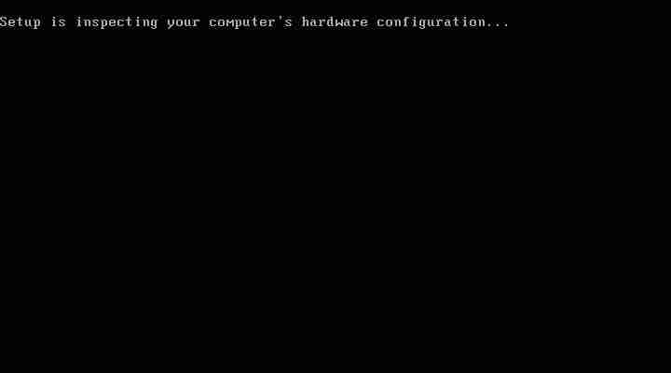
- You can press F6 if you need to install additional SCSI adapters or other mass-storage devices. If you do you will be asked to supply a floppy disk with the drivers and you CANNOT browse it (or a CD for that matter). Make sure you have one handy.
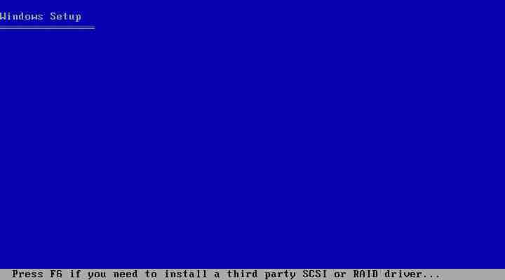
- f you want, you can press F2 to run the ASR sequence. For that you need a good backup created by the Windows Server 2003 backup program, and the ASR floppy disk. If you plan to install a new copy of 2003 - don't do anything.
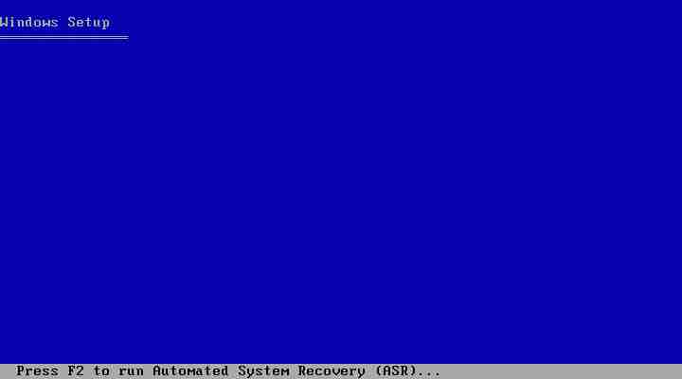
- Setup will load all the needed files and drivers.
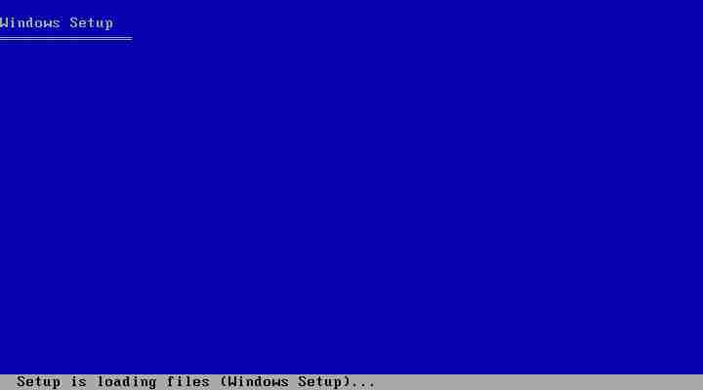
- Select To Setup Windows Server 2003 Now. If you want, and if you have a previous installation of the OS, you can try to fix it by pressing R. If not, just press ENTER.
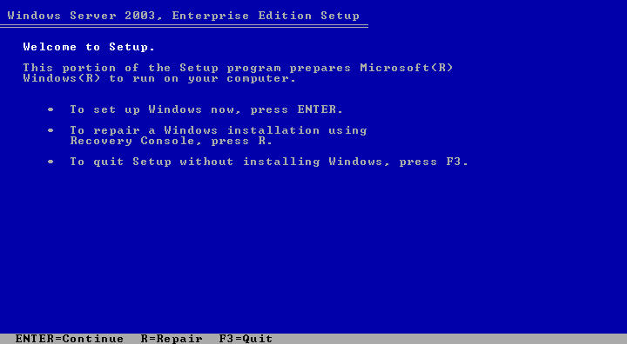
- Read and accept the licensing agreement and press F8 if you accept it.
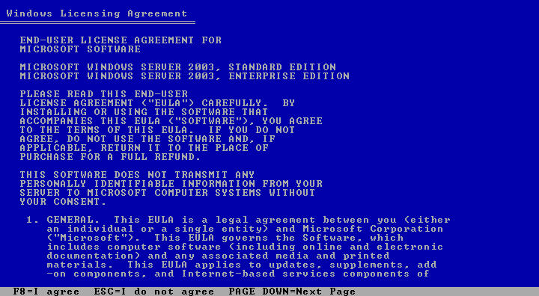
- Select or create the partition on which you will install Windows Server 2003. Depending upon your existing disk configuration choose one of the following:
- If the hard disk is unpartitioned, you can create and size the partition on which you will install Windows Server 2003.


